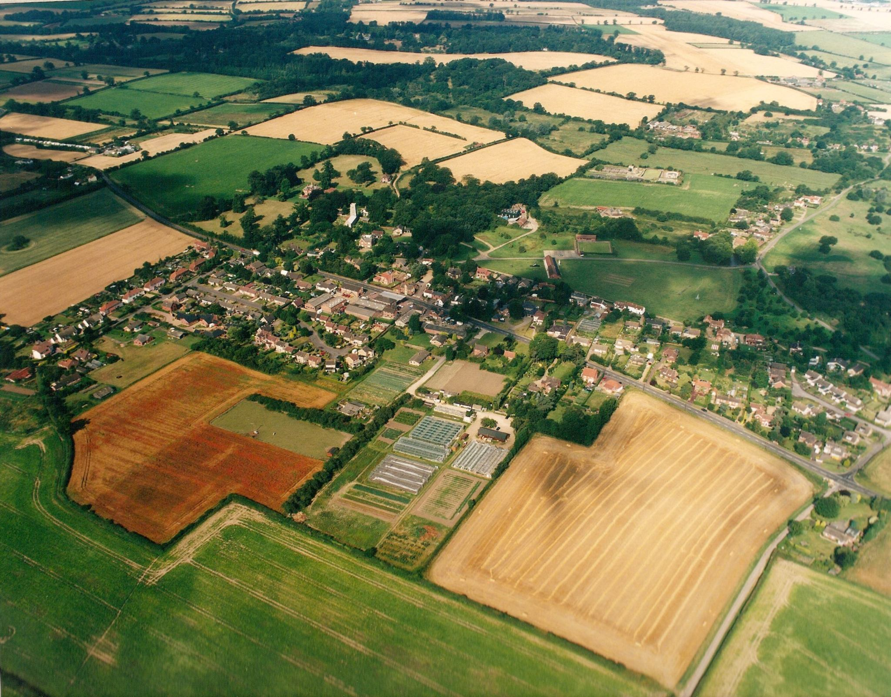

7:30pm at Swardeston Village Hall

on

Annual village meeting

Everyone is welcome come along and find out what is happening in your local community

Refreshments from 7.00pm
18th may 2017

